Semester Two

Insert School Logo

Examination 2019

Question/Answer booklet

MATHEMATICS
SPECIALIST UNITS 3 & 4

Section One:
Calculator-free

Student Name: _____________________________________
Teacher’s Name: _____________________________________

Time allowed for this section
Reading time before commencing work: five minutes
Working time for paper: fifty minutes

Material required/recommended for this section

To be provided by the supervisor
This Question/Answer booklet
Formula Sheet

To be provided by the candidate
Standard items: pens (blue/black preferred), pencils (including coloured), sharpener, correction tape/fluid, erasers, ruler, highlighters

Special Items: nil

Important note to candidates
No other items may be taken into the examination room. It is your responsibility to ensure that you do not have any unauthorised notes or other items of a non-personal nature in the examination room. If you have any unauthorised material with you, hand it to the supervisor before reading any further.

Structure of this paper

 | Number of questions available | Number of questions to be attempted | Working time (minutes) | Marks available | Percentage of exam
Section One  Calculator—free | 7 | 7 | 50 | 53 | 35
Section Two  Calculator—assumed | 12 | 12 | 100 | 97 | 65
 |  |  |  |  | 100

Instructions to candidates

- The rules for the conduct of Western Australian external examinations are detailed in the
Year 12 Information Handbook 2019. Sitting this examination implies that you agree to abide by these rules.

- Answer the questions according to the following instructions.

Show all your working clearly. Your working should be in sufficient detail to allow your
answers to be checked readily and for marks to be awarded for reasoning. Incorrect answers given without supporting reasoning cannot be allocated any marks. For any question or part question worth more than two marks, valid working or justification is required to receive full marks. If you repeat an answer to any question, ensure that you cancel the answer you do not wish to have marked.

It is recommended that you do not use pencil, except in diagrams.

- You must be careful to confine your responses to the specific questions asked and to follow any instructions that are specific to a particular question.

- Spare pages are included at the end of this booklet. They can be used for planning your responses and/or as additional space if required to continue an answer.
- Planning: If you use the spare pages for planning, indicate this clearly at the top of the page.
- Continuing an answer: If you need to use the space to continue an answer, indicate in the original answer space where the answer is continued, i.e. give the page number. Fill in the number of the question that you are continuing to answer at the top of the page.

- The Formula Sheet is not handed in with your Question/Answer Booklet.

Section One: Calculator–free 35% (53 marks)

This section has seven (7) questions. Attempt all questions. Write your answers in the spaces provided.

Working time: 50 minutes

Question 1 (5 marks)

Let $z=a+bi$ where $a,b∈R$. Determine the possible value(s) of the argument of $\overline{z}+\frac{z}{i}$ .

(5 marks)

Question 2 (10 marks)

(a) Solve the equation $z^{3}+8=0$ giving solutions in polar format $r\operatorname{cis}{θ}$. (3 marks)

(b) Sketch the solutions found in (a) on the grid provided below. (2 marks)

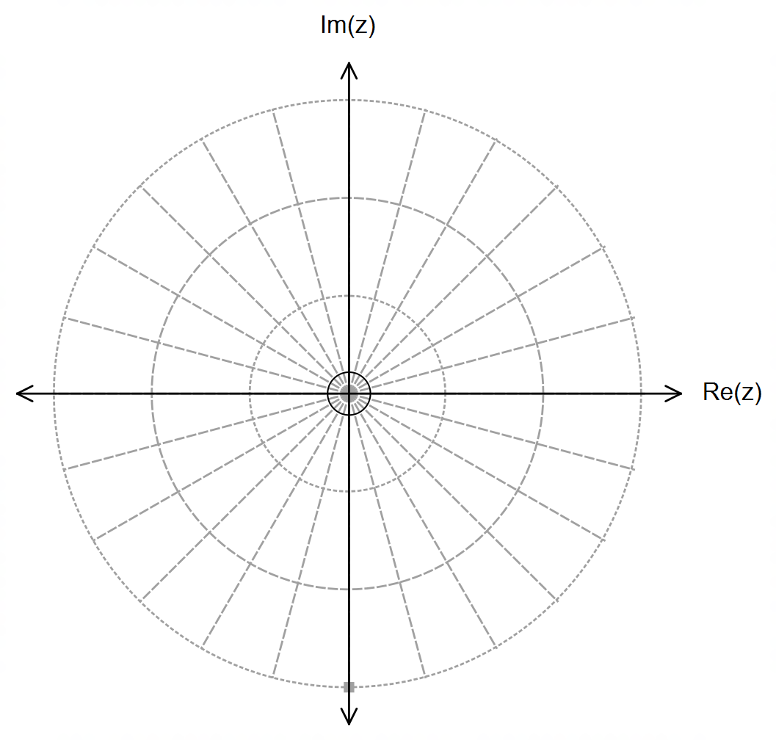

(Question 2 – Continued)

$P\left(z\right)=z^{5}-z^{4}-2z^{3}+8z^{2}-8z-16$ can be factorised into $P\left(z\right)=\left(z^{3}+8\right)Q\left(z\right)$.

(c) Determine $Q\left(z\right)$. (2 marks)

(d) Hence, solve the equation $z^{5}-z^{4}-2z^{3}+8z^{2}-8z-16=0$, giving all solutions
in Cartesian format $a+bi$. (3 marks)

Question 3 (8 marks)

Consider the definite integral:
$$\int_{0}^{2}{\frac{x}{\sqrt{x^{2}+4}}dx}$$

(a) By using the substitution $x=2\tan{θ}$, show that the integral can be written into the
expression shown below. State the value of $a$ and $b$. (4 marks)

$$\int_{0}^{2}{\frac{x}{\sqrt{x^{2}+4}}dx}=\int_{a}^{b}{\frac{2\tan{θ}}{\cos{θ}} dθ}$$

(Question 3 – Continued)

(b) Hence, or otherwise, evaluate the integral exactly. (4 marks)
Question 4 (10 marks)

Consider the function: $f\left(x\right)=\frac{x^{3} - 5x^{2} + 4x}{x - 1}$

(a) Simplify the function, and then state its domain and range.
(4 marks)

(b) Sketch the graph of $f(x)$ on the axes provided below clearly indicating all of its
graphical features. (2 marks)
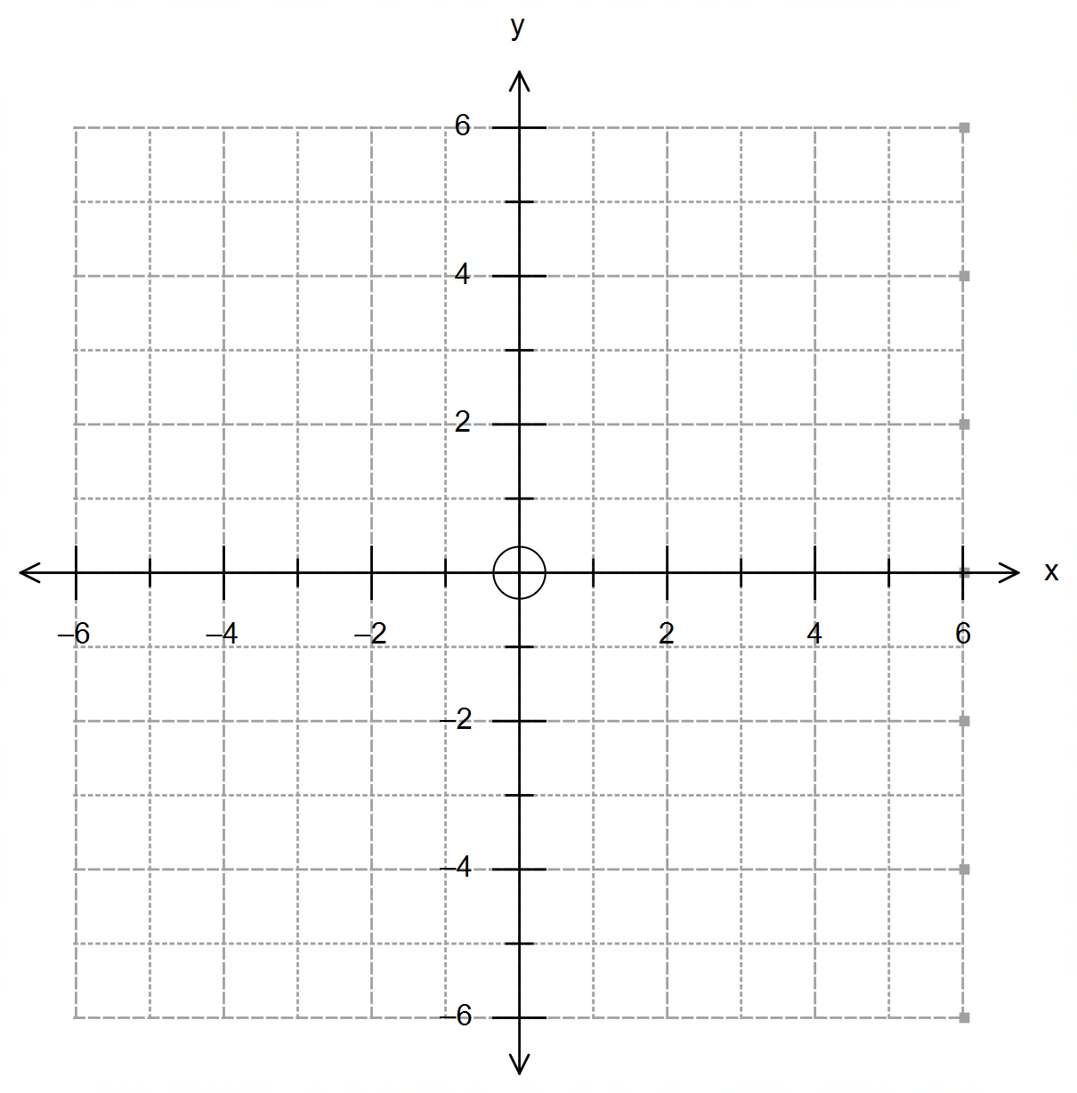

(Question 4 – Continued)

(c) The inverse function $f^{-1}(x)$ exists for the condition $x≤k$. Determine the maximum
value of $k$ and state the function $f^{-1}(x)$. (2 marks)

(d) Sketch the graph of $f^{-1}(x)$ on the same set of axes in (b), clearly labelling all relevant
points and features.
(2 marks)

Question 5 (6 marks)
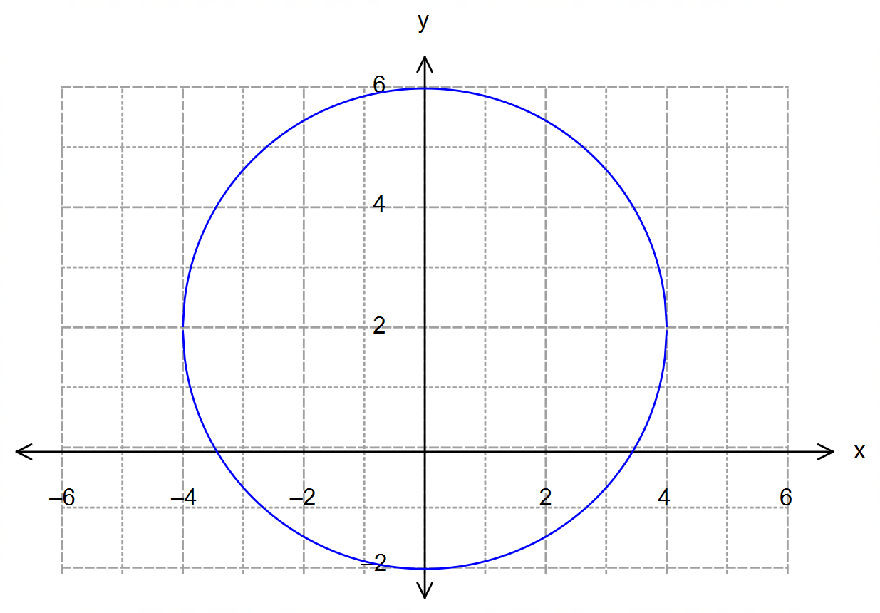

(a) State the vector equation of the circle shown on the graph above. (1 mark)

(b) Add to the graph above the line $r=\left(2λ-2\right)i+\left(λ+1\right)j$. Hence, determine the
exact coordinates of the point(s) of intersection between the line and the circle. (5 marks)

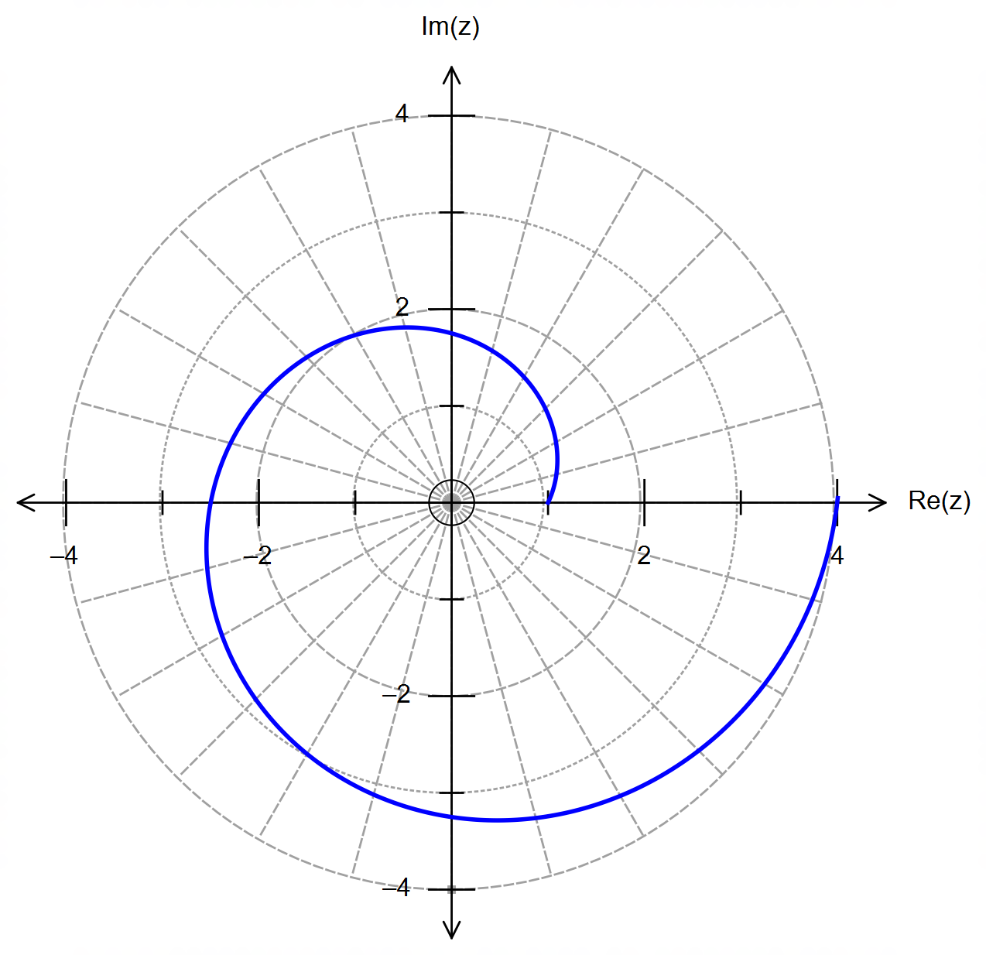Question 6 (6 marks)

The grid shows the spiral defined by:

$\left|z\right|=k×\arg\left(z\right)+1$

for $0≤\arg\left(z\right)≤2π$ and $k∈R$.

(a) Show that $k=\frac{3}{2π}$. (1 mark)

(b) Add to the grid above the locus defined by $\left|z\right|=2$. (1 mark)

(c) The spiral and your diagram intersect at the complex number $w$.
Determine $w$ in exact Cartesian form. (4 marks)

Question 7 (8 marks)

A raw milk tank truck has a cylindrical shaped tank that is 1m in diameter and 8m in length.
The tank is being filled from empty to half-full at a rate of 0.1 m³ of raw milk per minute.
The diagram below shows a cross section of the tank, where $x$ is the depth of the raw milk level.

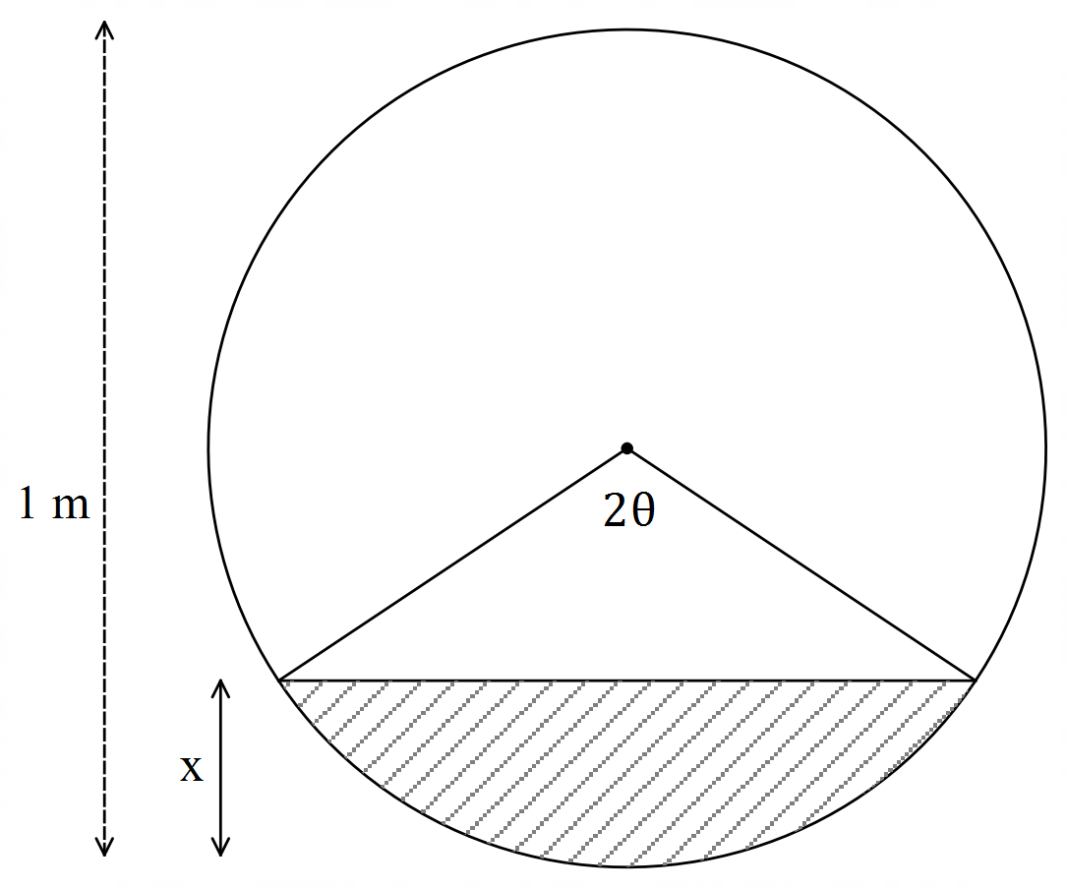

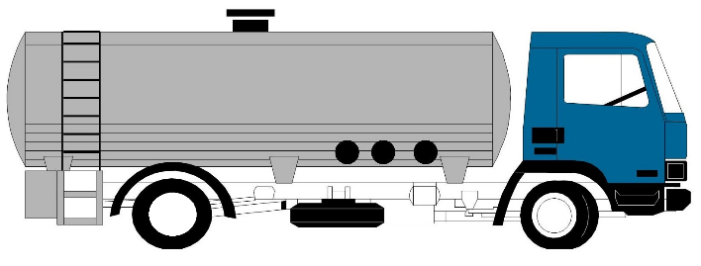

(a) Show that the volume $V \left[m^{3}\right]$ of raw milk in the tank is given by $V=2θ-\sin\left(2θ\right)$,
where $0≤θ≤\frac{π}{2}$.
(1 mark)

(b) Using the equation in (a), determine an expression for $\frac{dV}{dθ}$ in terms of $θ$. (1 mark)

(Question 7 – Continued)

(c) The diagram below shows a way to link the rising depth of the raw milk $x$ with the angle $θ$
and the radius of the circle. Use this diagram to express $x$ in terms of $θ$, and hence
show that: (3 marks)
$$\frac{dx}{dt}=\frac{1}{2}\sin{θ}\frac{dθ}{dt}$$

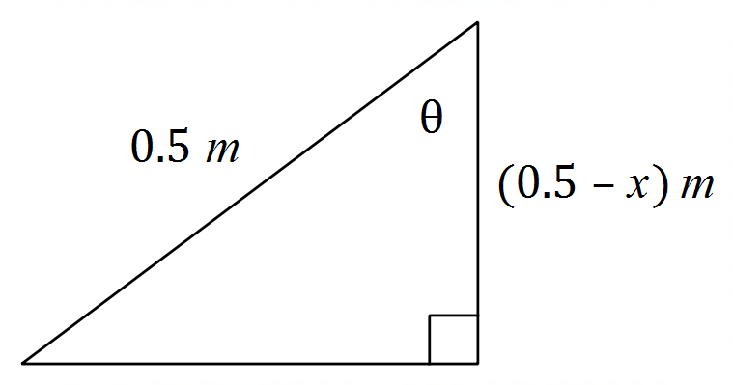

(d) Determine the exact rate at which the raw milk level is rising at the instant when the
raw milk is 25 cm deep. (3 marks)

End of Questions

Additional working space

Question number(s): ……………………

Additional working space

Question number(s): ……………………

Additional working space

Question number(s): ……………………

